

Development diary 2

Employability – CMP4271

9th of october 2020

By

Sean Colbourne

Territorial Acquisition



2.1 Premise

The game is based on the war of the rose’s, I worked closely with two others to make a tile-based game where players could trade resources, share troops and add power ups to make them tougher and more effective during battle.

2.2 Rules

To complete the game a player needs to collect all resource tiles on the game board and if there are no more tiles available whoever has the most tiles wins, rules are changeable with the inclusion of turn counters or timer meaning that players can control how long they play.

This is also a strategy game, players can form coalition’s so they have a better chance at winning, this is done is by trading or joining tile sets so they control a bigger part of the board, every time a player loses a confrontation they get stronger by being given more points which they can then spend on resources or battle tactics.

2.3 Material’s

The game board and resource cards are made up of 300 gsm laminated cardboard, meaning that they have longevity and should bring countless fun memories for future generations.

**Figure 1.**

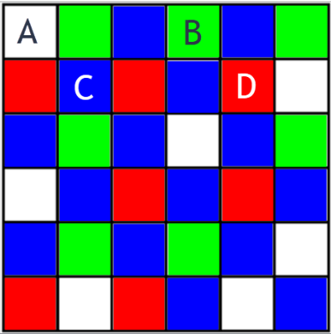

The game board is split up into multiple coloured sections and allow the player to perform different actions, heal/hire troops **[A]**, defend **[B]**, attack/defend **[C]** and attack **[D]**.

Software

Google Slides – this was used to create the corresponding presentation and present it to our peers.

Google slides was used so that the team could contribute to the same document, meaning that the presentation was prepared quicker, and we could communicate our ideas effectively.

2.4 How it’s played

Players roll a die to determine who goes first, this is based on the highest roll, if there’s a draw then the players who drew re-roll until one rolls a higher number, the players then take turns rolling the die which determines the amount of tiles that they can move.

It is a 62 board; each player moves around this, the number of moves is dependent upon the roll of the die, you move along tiles adjacent to the one you are standing on, the grid is split into different coloured sections see Fig.1 above.

Play testing

Due to the current pandemic we had to test the game remotely however, this was done as an internal testing cycle rather than an external one for ease of use, as my personal preference I Drew a quick mock-up of the board and used some dice I had lying around to play test it.

**Figure 2.**

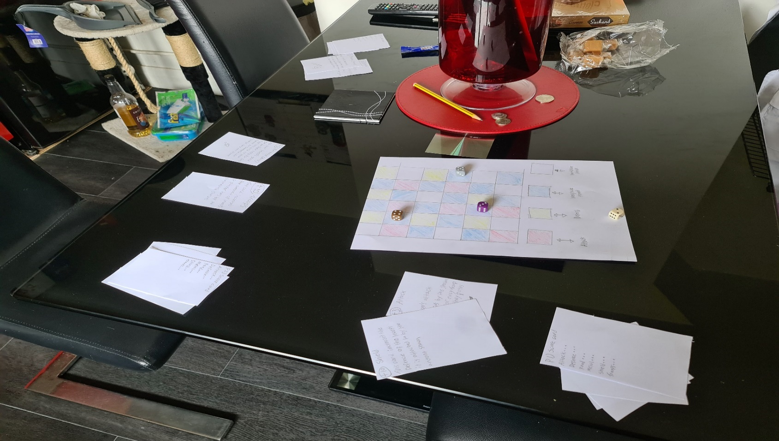

B

D

E

C

A

A quickly drawn prototype of the board **[A]**, player score card used to keep track of points, troop’s and bonuses **[B]**, where the player kept the bonus cards during play **[C]**, the different coloured dice shows a visual representation of where the player was **[D]** the die that was used for movement to adjacent tiles **[E]**.

2.5 Teamwork experience

We started off great as a team however as we progressed through the task things were changed that did not need changing such as the theme and style of the board game, although these choices occurred we still managed to get a prototype and play test it to see if it was fun and if others would enjoy it.

The team consisted of Sean Colbourne, Ali Noorani and Will Connell

2.6 Reflection

I have learnt that in some cases I should be more defensive of my ideas and ideas that have been proposed from other members of the team. The game idea and theme went through many iterations during the design and creation processes, meaning that we had to swap out created assets that were ready and usable for a visual representation to a less finished and unclear one.

I must also make sure that hardware such as headphones and microphones are working in the future, as the lack of headset implied that I may have been avoiding the task or may not have contributed at all whilst also putting extra stress on the team members who then had to cover what I was to present.